TASK 2 – Choose the Data Types 4 Marks
Bloom’s Level: K4 – Analyse
Select a C data type for every data item identified in Task 1.
Discuss:
• The type chosen (char, short, int, long, long long, unsigned, float, double) and its size
using sizeof on your system
• The range of each type using limits.h and float.h, and whether it is sufficient for a district
• Why money should not be stored as float rupees, and the alternative of storing paise in an
integer
• What happens to a 16-bit unsigned meter register after 65535
Show one example where float gives a wrong total when 4,000 bills are added, and how your
choice avoids it.
Complete the Code
Complete TODO 1 below without using if–else, and execute the program.

#include &lt;stdio.h&gt;
#include &lt;limits.h&gt;
/* The meter register is a 16-bit counter: after 65535 it rolls over to 0. */
typedef unsigned short meter_t;
unsigned int consumption(meter_t previous, meter_t current)
{
// TODO 1: Return the units consumed, correct even when the register has rolled over
// (current &lt; previous); use unsigned 16-bit arithmetic instead of an if-else
}
int main(void)
{
printf(&quot;sizeof(meter_t) = %zu bytes, maximum reading = %u\n&quot;,
sizeof(meter_t), (unsigned)USHRT_MAX);
printf(&quot;Consumption: %u units\n&quot;, consumption(1200, 1530));
printf(&quot;Consumption: %u units\n&quot;, consumption(65400, 120)); /* rolled over */
return 0;
}

Expected output:
sizeof(meter_t) = 2 bytes, maximum reading = 65535
Consumption: 330 units
Consumption: 256 units

Explain why the second result is 256 and not a negative number.
Alternative Concept and Complexity Analysis
Suppose money were stored as double rupees instead of long paise. What would the billing
solution be, and where would rounding be applied? Analyse the time per addition (O(1) in both)
and the space per value, and compare how the rounding error grows when n bills are added.
Evidence Expected
A justified data-type table with sizes and ranges, and evidence of one precision or overflow
problem with its resolution.
TASK 2 – Choose the Data Type :
1. Data Types, Sizes and Ranges
The appropriate C data types are selected based on the size, range and accuracy required for each data item. The sizes below are typical for a modern 64-bit system and must be verified using sizeof() on the actual system.
Data type | Typical size | Range / precision | Application
char | 1 byte | −128 to 127 (signed) | Single characters
short | 2 bytes | −32,768 to 32,767 | Small integer values
unsigned short | 2 bytes | 0 to 65,535 | 16-bit meter register
int | 4 bytes | −2,147,483,648 to 2,147,483,647 | Units consumed
long | 4 or 8 bytes | System-dependent | Large integer values
long long | 8 bytes | Typically −9.22 × 10¹⁸ to 9.22 × 10¹⁸ | Very large totals
unsigned int | Typically 4 bytes | 0 to 4,294,967,295 | Non-negative consumption
float | 4 bytes | Approximately 6–7 significant decimal digits | Approximate measurements
double | 8 bytes | Approximately 15–16 significant decimal digits | Higher-precision calculations
The exact sizes and limits can be checked using sizeof(), limits.h and float.h. For district-level billing, integer types with sufficient capacity should be used for total consumption and monetary values.
2. Why Money Should Be Stored as Integer Paise
Storing money as float rupees can introduce rounding errors because many decimal fractions cannot be represented exactly in binary floating-point format.
Example: Suppose 4,000 bills each contain ₹0.10.
- Expected total = 4,000 × ₹0.10 = ₹400.00.
- A float may represent ₹0.10 approximately, causing a small accumulated error.
- Storing each bill as 10 paise using an integer gives \(4000 \times 10 = 40000\) paise, which is exactly ₹400.00.
Therefore, monetary values should be stored as integer paise, using a sufficiently large type such as long long. Conversion to rupees should be performed only when displaying the result.
3. Completed C Program
#include <stdio.h>
#include <limits.h>
#include <float.h>

/* The meter register is a 16-bit counter */
typedef unsigned short meter_t;

unsigned int consumption(meter_t previous, meter_t current)
{
/* TODO 1: Handle rollover without if-else */
return (meter_t)((unsigned int)current -
(unsigned int)previous);
}

int main(void)
{
printf("sizeof(meter_t) = %zu bytes, maximum reading = %u\n",
sizeof(meter_t), (unsigned)USHRT_MAX);

printf("Consumption: %u units\n", consumption(1200, 1530));
printf("Consumption: %u units\n", consumption(65400, 120));

printf("\nFloat precision: %d decimal digits\n", FLT_DIG);
printf("Double precision: %d decimal digits\n", DBL_DIG);

return 0;
}
Expected Output
sizeof(meter_t) = 2 bytes, maximum reading = 65535
Consumption: 330 units
Consumption: 256 units

Float precision: 6 decimal digits
Double precision: 15 decimal digits
4. Explanation of Meter Register Rollover
A 16-bit unsigned meter register stores values from 0 to 65,535. After reaching 65,535, the next reading becomes 0.
For the second example:
- Previous reading = 65,400
- Current reading = 120
- Maximum register value = 65,535
The consumption is:
\[ \begin{aligned} \text{Consumption} &=(65535-65400)+1+120\\ &=135+1+120\\ &=\boxed{256\text{ units}} \end{aligned} \]
The result is not negative because conversion to meter_t wraps the subtraction result modulo \(65536\), the number of possible register values. The result is then returned as an unsigned integer.
5. Alternative Concept: Using double for Money
If money is stored as double rupees instead of integer paise, the billing program can use floating-point addition.
#include <stdio.h>

int main(void)
{
double total = 0.0;
double bill = 0.10;

for (int i = 0; i < 4000; i++)
total += bill;

printf("Total bill = %.2f rupees\n", total);

return 0;
}
The result may be approximately ₹400.00, but the internal value can contain a small rounding error because 0.10 cannot be represented exactly in binary floating-point format.
Rounding should be applied at the appropriate billing stage, usually when converting the final calculated amount to paise or displaying the amount to two decimal places. Rounding every intermediate addition can introduce additional errors.
Integer paise avoids this problem for amounts expressed in whole paise.
6. Time and Space Complexity Analysis
Method | Time per addition | Space per value | Accuracy
Integer paise (long long) | O(1) | Typically 8 bytes | Exact within the integer range
double rupees | (O(1) | Typically 8 bytes | Approximate
float rupees | O(1) | Typically 4 bytes | Lower precision
Both methods require constant time, O(1), for each addition. For (n) bills, the total addition time is (O(n)
With floating-point values, rounding errors may accumulate as the number of bills increases. The exact error depends on the values, their order and the number of operations; it does not necessarily increase at a fixed rate. Integer paise eliminates floating-point rounding errors for additions, provided the integer does not overflow.

Code and output:
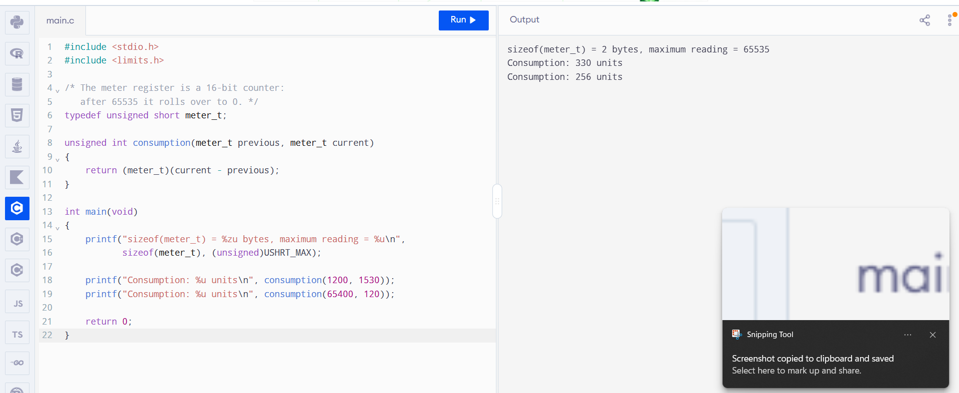
7. Conclusion
The appropriate data types improve the accuracy and reliability of district-level electricity billing. The unsigned short type is suitable for a 16-bit meter register, while long long is suitable for large monetary totals stored in paise. Integer arithmetic correctly handles meter rollover and avoids floating-point errors in monetary addition. The sizeof(), limits.h and float.h facilities help verify the sizes, ranges and precision of the chosen types.

